IT6042 Advanced Mobile Development
Design Document
Student ID: 20240259
Student Name: Syed Yousuf Subzwari

Contents
Mobile App Development 3
Mobile App Title 3
App goals and Objective 3
Why Develop This App? 3
Features of the App 3
Target Audience 4
Prototype 4
Screenshots of Actual Mobile App 5
App Testing Methods and Proof 8
Testing Strategy 8
Proof/Evidence 9

Mobile App Development

Mobile App Title
ABC Security Hub
Admin login :
Email: admintest@abc.com
Pass: abc123
Basic Login :
Email: tester@abc.com
Pass: abc123

App goals and Objective
Provide a secure, efficient, and user-friendly mobile tool for security guards to document and submit reports in real time efficiently and without much hassle.
Objectives:
- Simplify incident reporting with templates and autofill.
- Enable offline data capture (SQLite) and cloud synchronization (Firebase).
- Provide geotagged reports with photo/video evidence.
- Allow admins to review, manage, and track reports.
- Improve accountability and reduce paperwork delays.

Why Develop This App?
Security guards often rely on manual paperwork, emails and calls for reporting systems. These create delays, risk of lost information, and limited oversight for managers. By developing a cross-platform mobile app, guards can:
- Report incidents instantly (even offline).
- Capture accurate details (details, geolocation, photo/video evidence).
- Improve communication with admins/managers.
- Enhance security operations with centralized reporting and tracking.

Features of the App
- User Authentication, for guard login and Admin login.
- Dashboard / landing page for quick access to reports, history, and profile.
- Report Templates for a few reports such as Daily Report, Incident/Damage, Lost & Found, Maintenance for easy and quick reporting.
- Camera Integration for taking photos/videos and scan inside the app.
- Geolocation Tagging for automatically attach location data to reports.
- Offline Support (SQLite) to save reports locally when offline.
- Cloud Sync (Firebase) for upload to Firebase Firestore + Storage.
- Autofill to pre-fill or quickly fill guard info, date/time, and station with quick selections.
- Responsive UI for Portrait and landscape support for multiple devices and OS.
- Drawer menu nav and bottom tab main navigation.
- Admin Features for viewing submitted reports, filter by status, track history.

Target Audience
Primary Users: Security guards on duty who need fast, structured report submission.
Secondary Users: Security managers or admin staff who monitor, review, and analyse reports.

Prototype

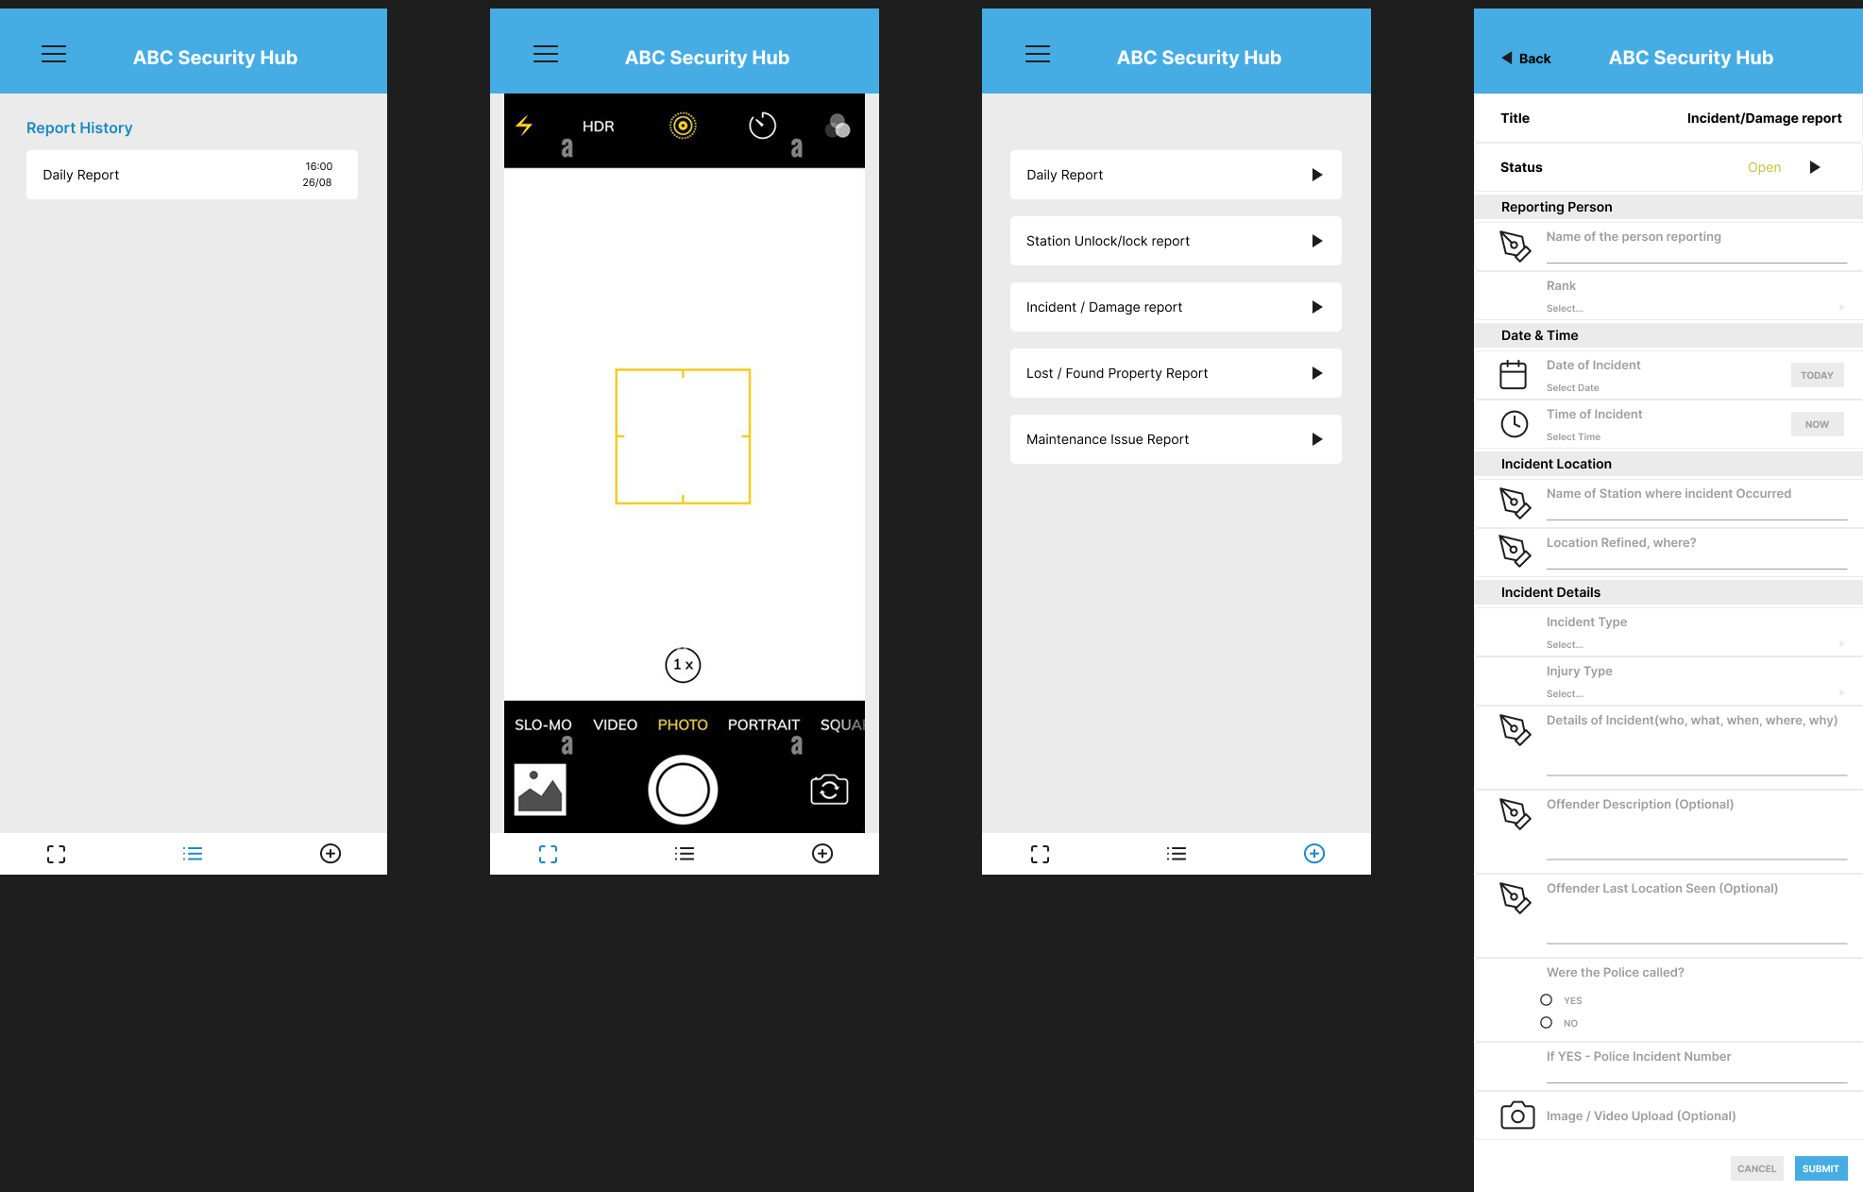

Navigation Drawer: User Profile, Location, Logout.
Dashboard: Quick links to report templates.
Camera Screen: Integrated photo, video capture and scanning.
Report Form Screen: Preset template for easy fill in / autofill and quick reporting.
Report History: Submitted reports history with timestamps.

Screenshots of Actual Mobile App

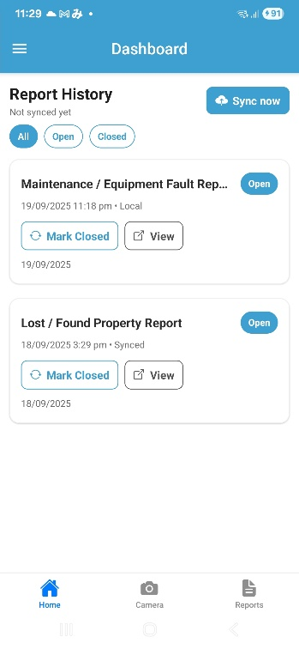
Main Page / Dashboard

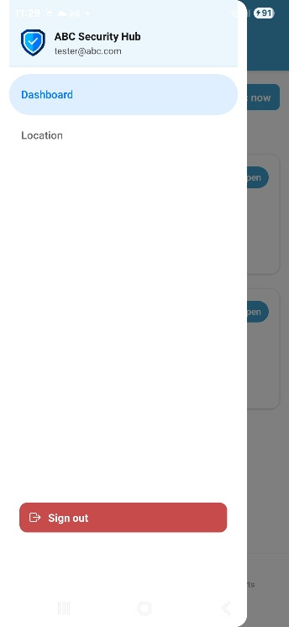
Sidebar View

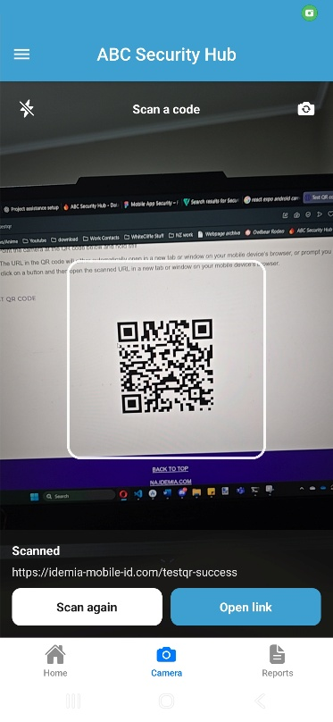
Scan / Camera Page

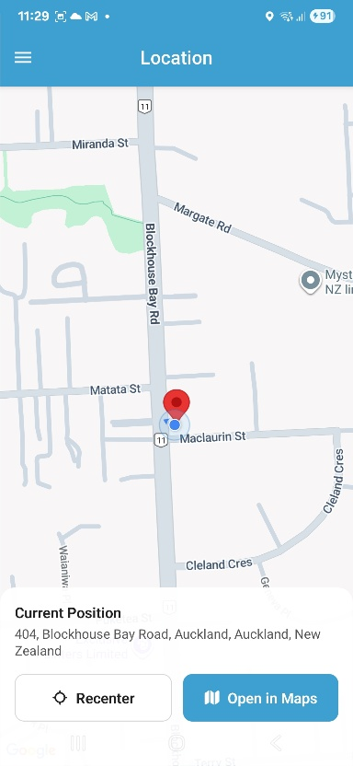
Map / location page

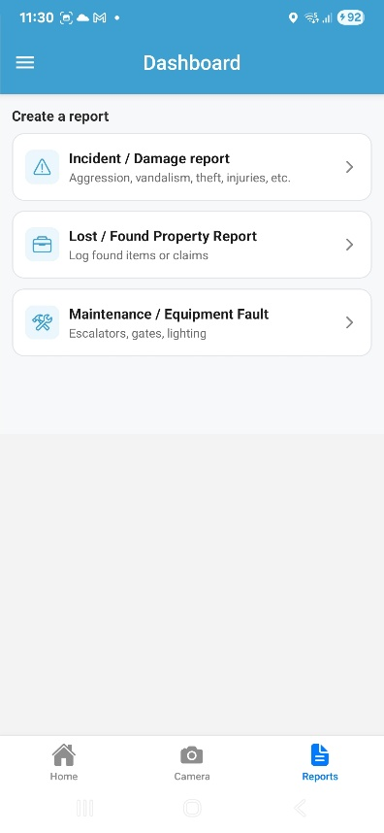
Reports list page

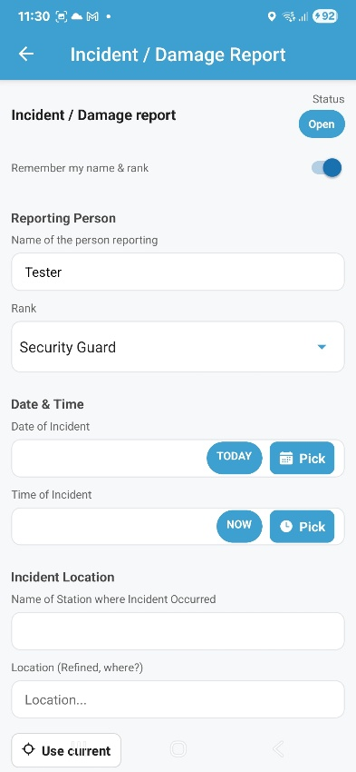
Incident report Screen

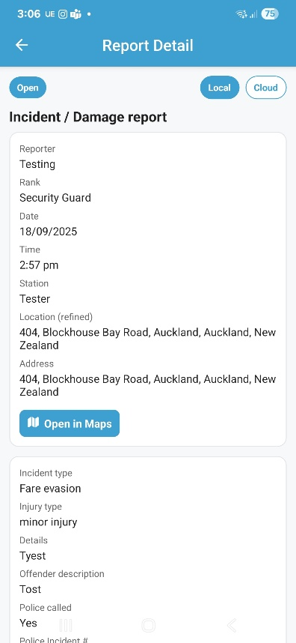
Submitted Report View

App Testing Methods and Proof

Testing Strategy
- Functional Testing: Validate login, navigation, report creation, offline save, cloud sync.
- Cross platform Testing: Test on Android + iOS devices and simulators.
- Usability Testing: Run with guards/admin, observe reporting flow.
- Offline Testing: Submit reports without internet verify local SQLite save and later sync.
- Performance Testing: Check response times, photo upload speeds.
- Security Testing: Validate Firebase auth, database rules, secure data transmission.

Proof/Evidence
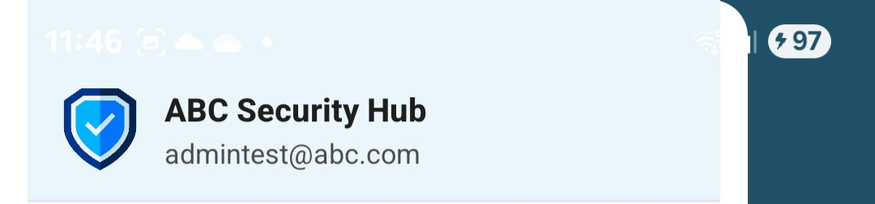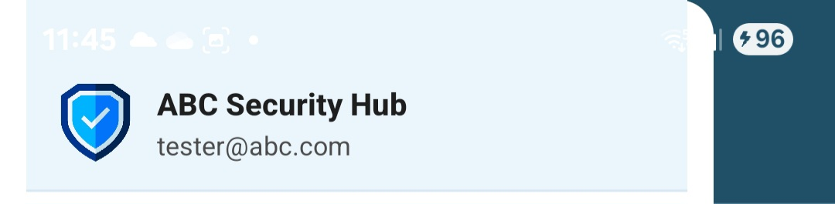
Different accounts logged in successfully
Navigation functional from listed directories
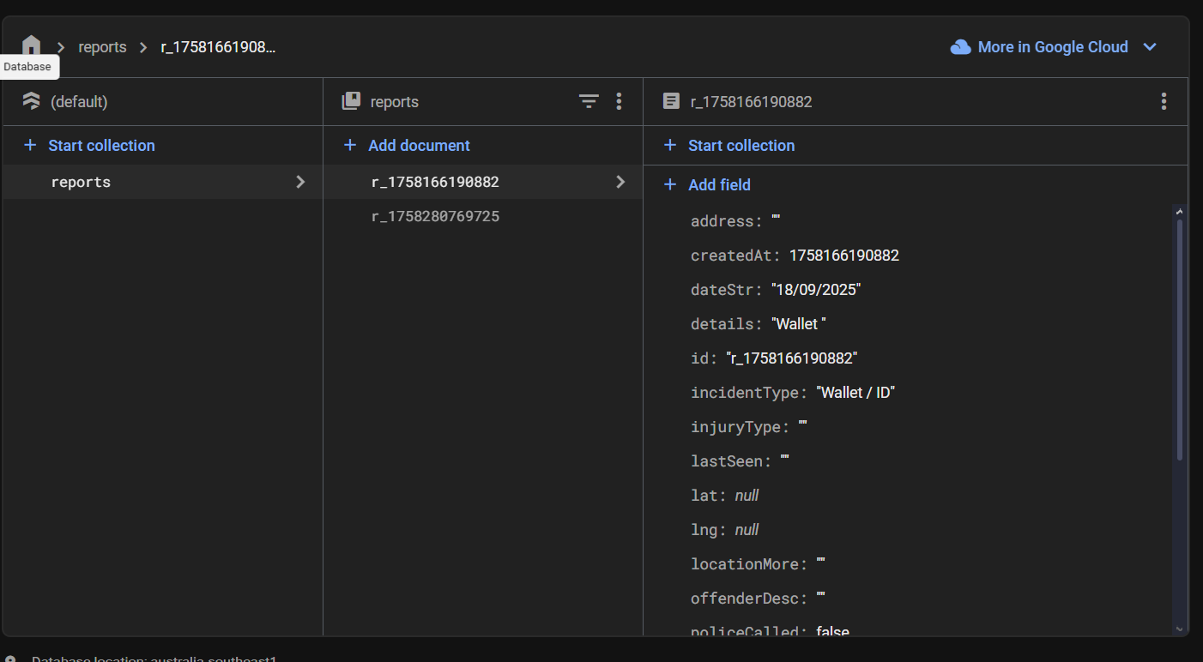
Successful report creation and cloud sync.
